TRACKIT ADMIN PANEL
Purpose: This document provides a detailed guide to the TrackIt Admin Panel.
Scope: This document covers the following topics:
- The Configuration module
- Milestone configuration
  - Overview of the Milestone configuration sub-module
  - Creating and maintaining Milestone Types
  - Creating Simple Fields
  - Maintaining Grouped Fields
  - Template Builder

The Configuration module
- The Configuration tab, when clicked, displays a dropdown menu containing a list of application modules which can be selected to access the configuration/settings pertaining to that module. The available choices are:
- Milestone: For configuring milestone types and templates in the system. App admins can use this sub-module to create, edit, map, and manage milestone types and templates effectively with the help of customizable fields and layout builders.

Overview of the Milestone configuration sub-module
- The configuration section for Milestone contains two tabs viz. "Milestone Type" and "Template".
- Under the tab "Milestone Type", the app admin can view, edit or map (to a template) all of the existing milestone types.
- Under the tab "Template", the app admin should be able to locate three more tabs viz. “Simple Fields", "Grouped Fields" and "Template Builder". Using the section pertaining to "Simple Fields" tab, the app admin can create and maintain standalone fields, while the "Grouped Fields" section can be used to create and maintain grouped fields. The list of existing templates and the layout builder for creating and maintaining templates can be located under the "Template Builder" tab.

Creating and maintaining Milestone Types
- The name and description of an existing milestone type can be modified by clicking the associated Edit button.
- At any point of time, the admin can choose to activate or deactivate a particular milestone by clicking the toggle switch (depicted in green) for that corresponding milestone.
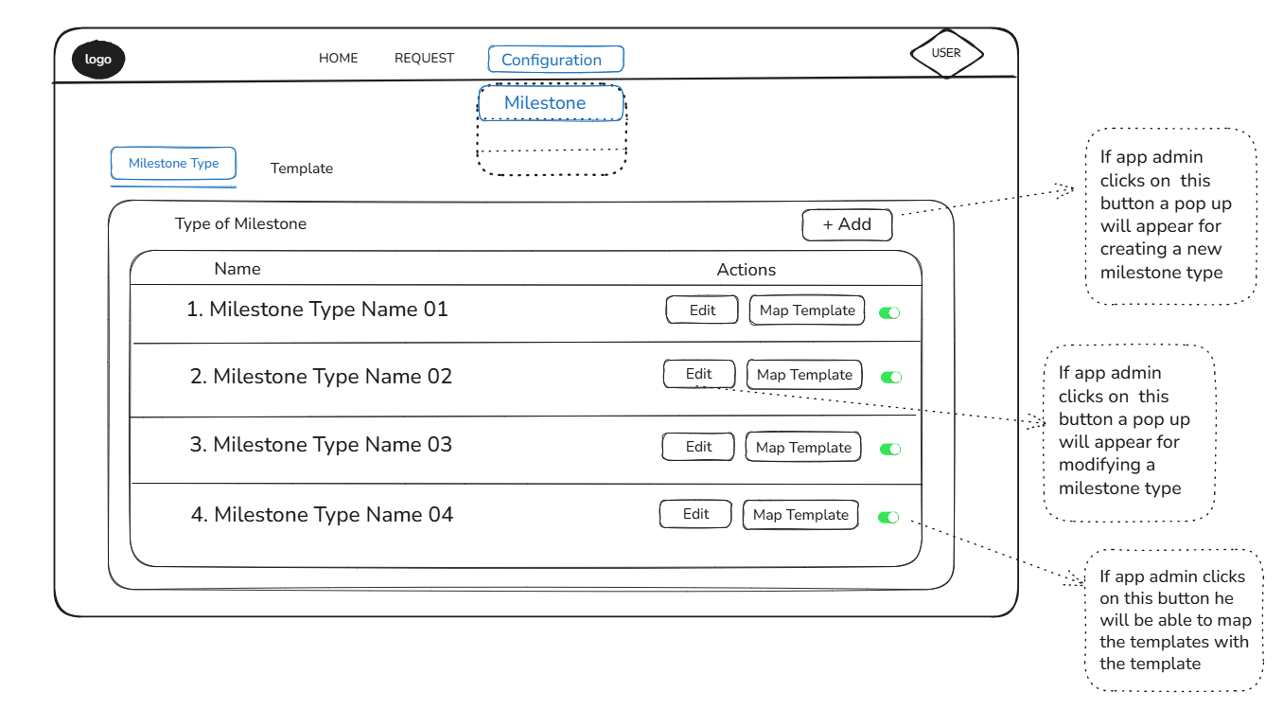
Figure: 1
- A new milestone type can be added by clicking the Add button (depicted in the picture above). The window that pops up (refer to the picture below) contains two fields that allows the app admin to enter the name and description of the milestone type.
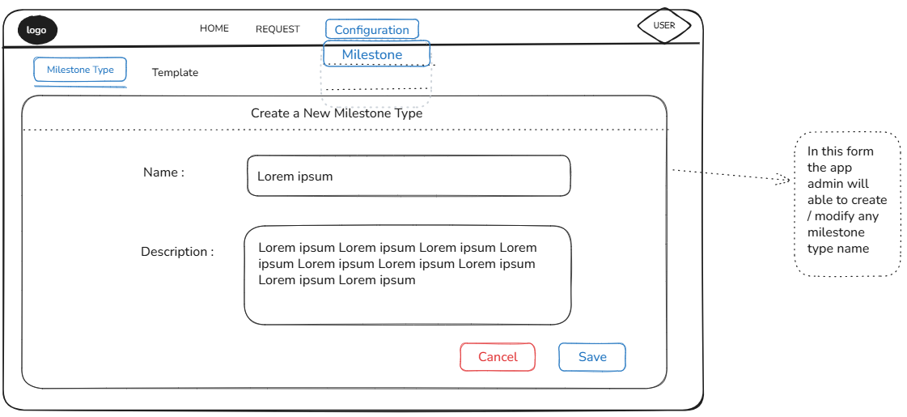
Figure: 2

The app admin is then prompted to select a milestone template for the newly created milestone type. The pop-up window provides a list of pre-configured templates to select from. Selecting a template and clicking the Save button maps the Milestone in context to that template.

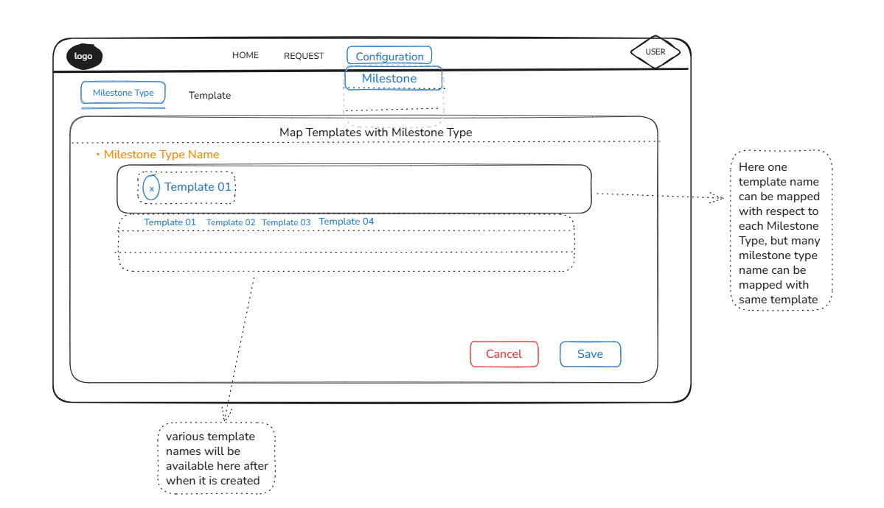
Figure: 3

- An existing milestone type to milestone template mapping can be changed by clicking the "Map Template" button corresponding to the Milestone Type in question.
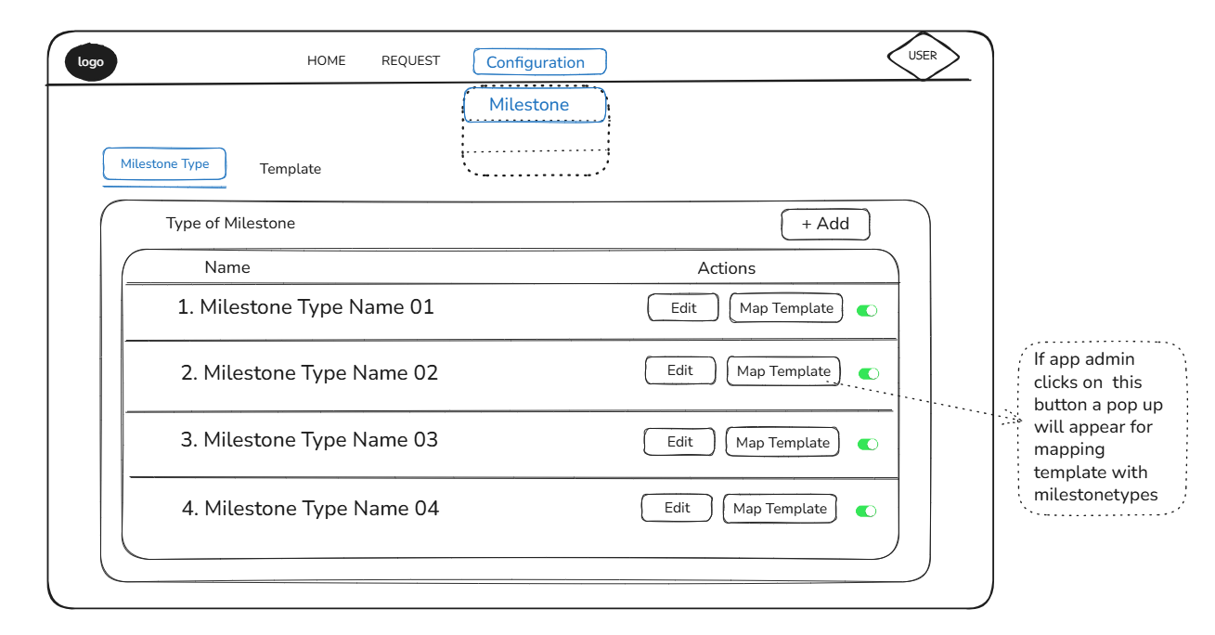
Figure: 4

Creating Simple Fields
- The section for creating and maintaining Simple Fields is split in two panes:
- The left pane lists existing fields, each of which can be selected to edit that particular field. The topmost field will be selected by default when the window loads.
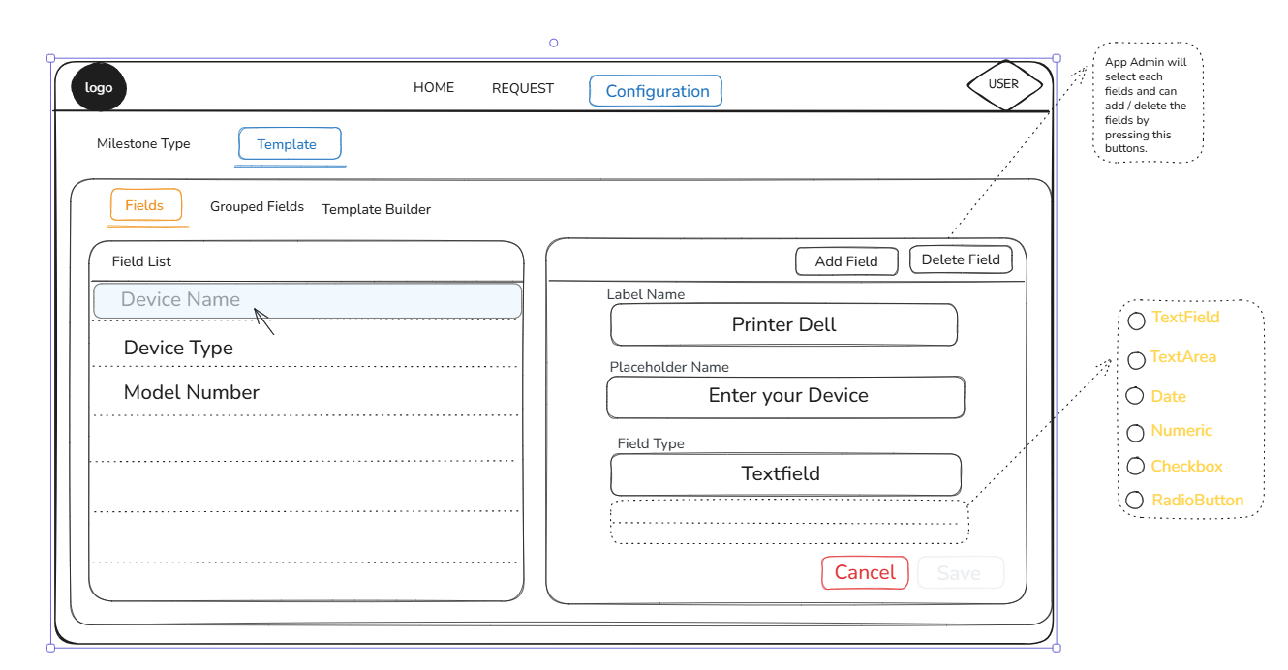
Figure: 5

- The right pane houses the Add Field and Delete Field buttons as well as field attributes for the selected field.
- The app admin can modify any of the existing attributes of a selected field viz. "Field Name", "Placeholder" or "Field Category" by changing any of the attribute values and then clicking the Save button, which is enabled only when a field attribute is changed or when a new field is created.
- Clicking the Add Field button clears the field selection and allows the user to enter values for the attributes of the new field.
- Selecting a particular field and then clicking the Delete Field button deletes that field.
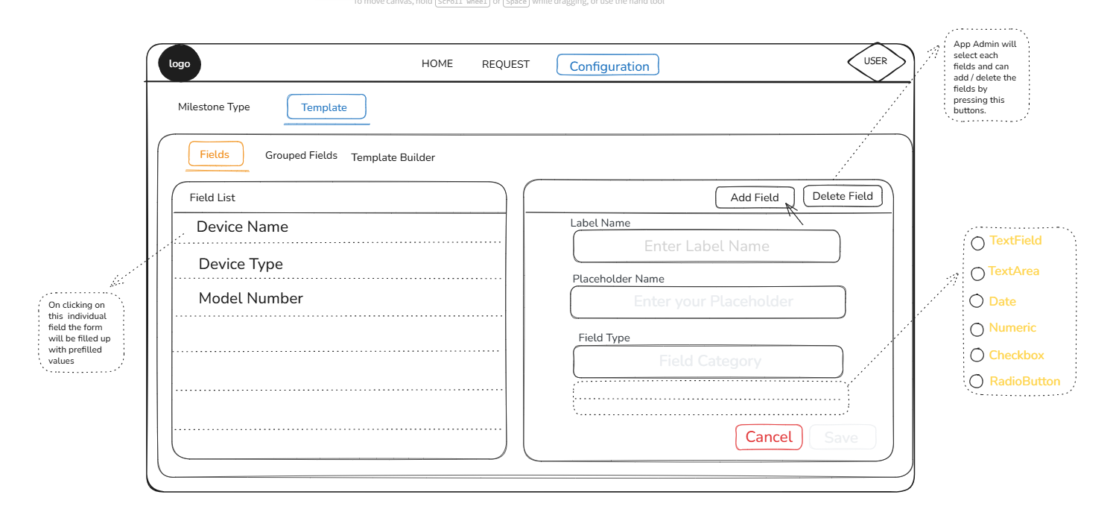
Figure: 6

Creating and Maintaining Grouped Fields
- Like Simple Fields, the section for Grouped Fields is also split in two panes:
- The left pane lists existing grouped fields, each of which can be selected to edit that grouped field. The topmost grouped field will be selected by default when the window loads.
- The right pane contains the following:
- "Add Group", "Delete Group" and "Duplicate Group" buttons for creating a new group, deleting an existing group and creating a copy of an existing group in that order
- a dropdown for selecting the Grid Size of the Layout Builder grid
- a textbox for entering the name of the grouped field
- a Layout Builder for arranging and displaying the constituent fields of the grouped field currently in selection
- a small frame to the right of the Layout Builder, containing the field attributes of the selected constituent field
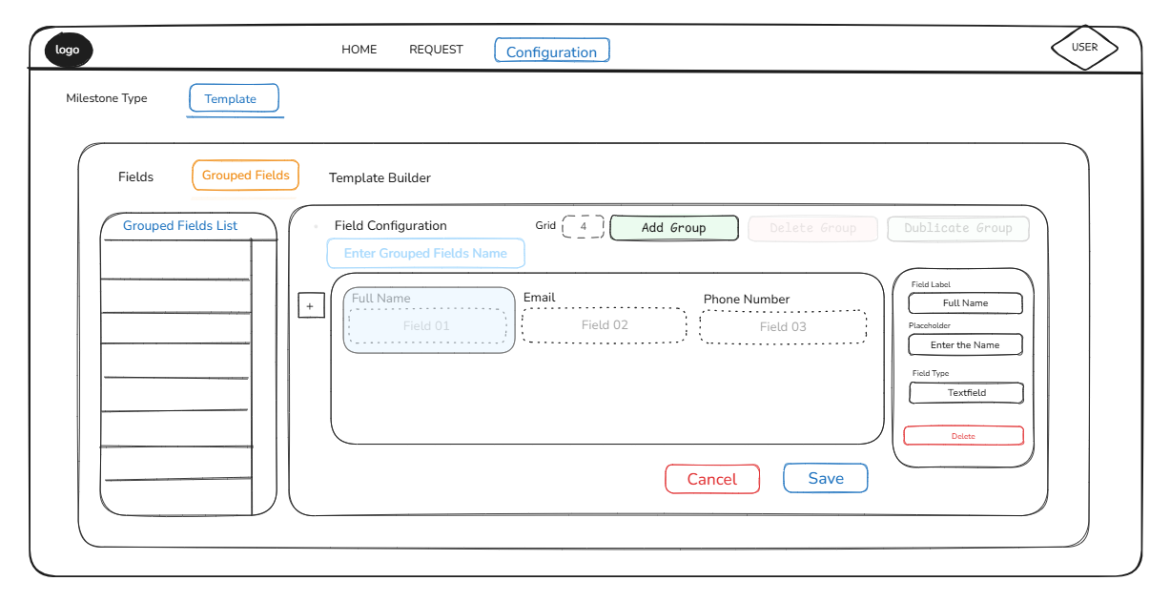
Figure: 7

- When adding a grouped field, the app admin must enter the name of the grouped field in the textbox provided and then proceed to add the constituent fields one by one using the [+] button (located to the left of the Grouped Field Layout Builder). Any of the constituent fields can be selected to view/add/modify its attributes.
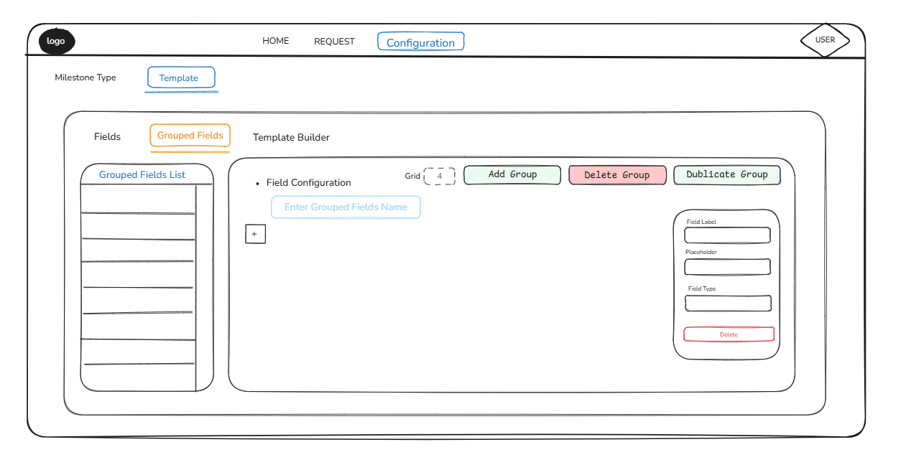
Figure: 8

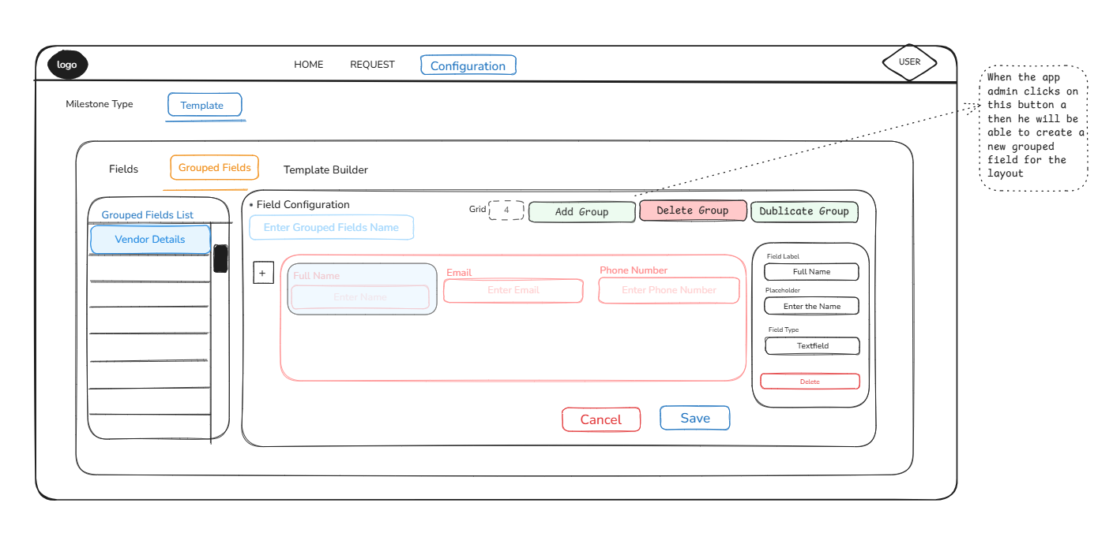
Figure: 9

- New constituent fields can be added to an existing grouped field by first selecting the grouped field in the left pane, followed by clicking the [+] button beside the Layout Builder in the right pane.
- Any of the existing constituent fields of a grouped field currently in selection can be edited by first selecting the constituent field that needs to be modified and then selecting any of its attributes to change its value. Unless updated, the Save button remains deactivated when viewing details of an existing grouped field.
- Selecting a constituent field and then clicking the [Delete] button in the attributes frame deletes that field.
- An existing grouped field can be copied to create a new grouped field with the same constituent fields but with a new name. Needless to say, once duplicated, any of the existing constituent fields can be removed and extra ones can be added as required.
- Selecting a grouped field from the list to the left and then clicking the "Delete Group" button to the right deletes that grouped field.
- Constituent fields are initially arranged by the system using a default layout, which can be changed by the app admin at any point of time. The default size of the layout builder grid is 16. However, this can be changed to a lower value for finer adjustment of the constituent fields with regard to their size and position. The width of a text box, text area or a CQE can be increased or decreased by dragging its left or right edge. The height of a text area or a CQE can be increased or decreased by dragging its top or bottom edge. The position of constituent fields can be changed by dragging the field in question and then dropping it at the intended location.
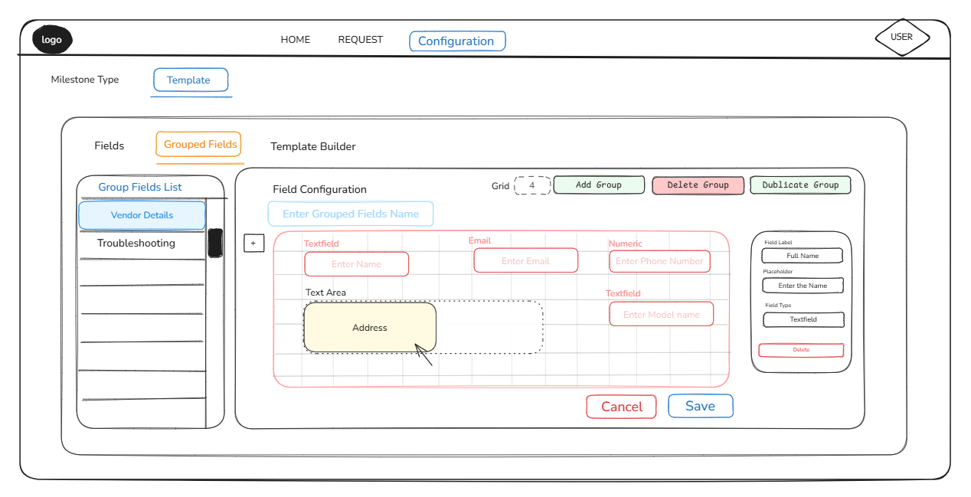
Figure: 10

Template Builder
- The Template Builder is a utility for creating and managing Milestone Templates. It consists of two panes, the left one containing a list of existing templates and the right pane housing the layout builder for arranging the fields (simple or grouped) associated with the template currently in selection or those pertaining to a new template being created. The right pane also contains the buttons "Create", "Edit" and "Delete" for creating a new template, editing an existing and deleting an existing template in that order. Additionally, there’s a small frame to the right of the layout builder, only for displaying the attributes of the member fields (simple fields and constituent fields of grouped fields) tied to the template currently in selection.
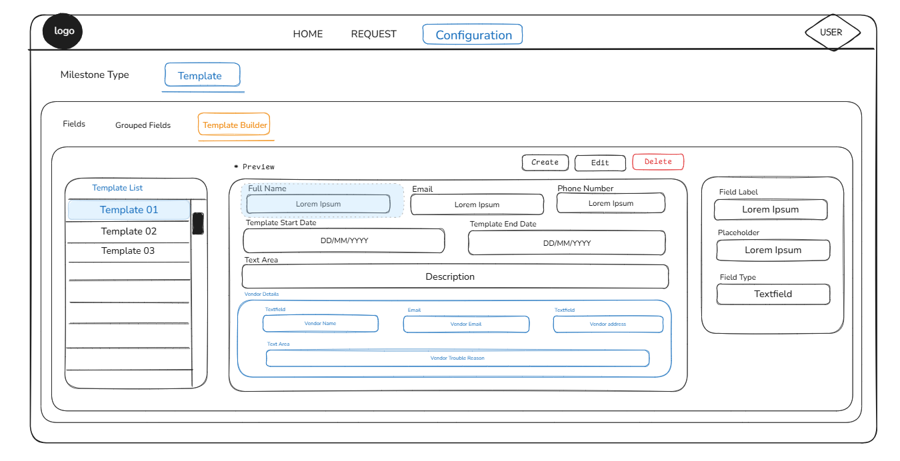
Figure: 11

- Existing templates can be activated or deactivated using the toggle switch for that template (refer to the picture above).
- Selecting an existing template and then clicking the "Delete" button deletes that template. Templates can be deleted only if the following conditions are met:
- The template in question is currently not tied to a milestone type.
- No milestone type mapped to that template was ever instantiated.
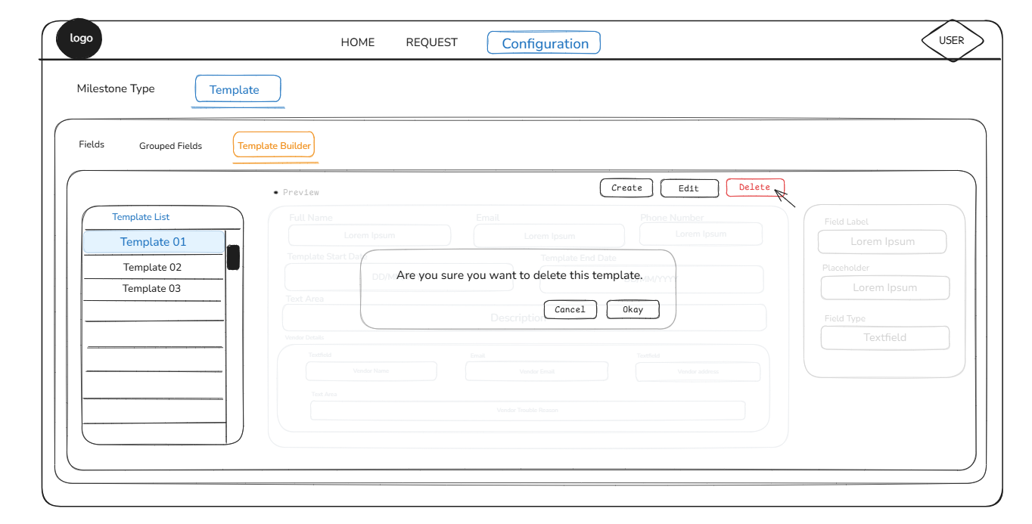
Figure: 12

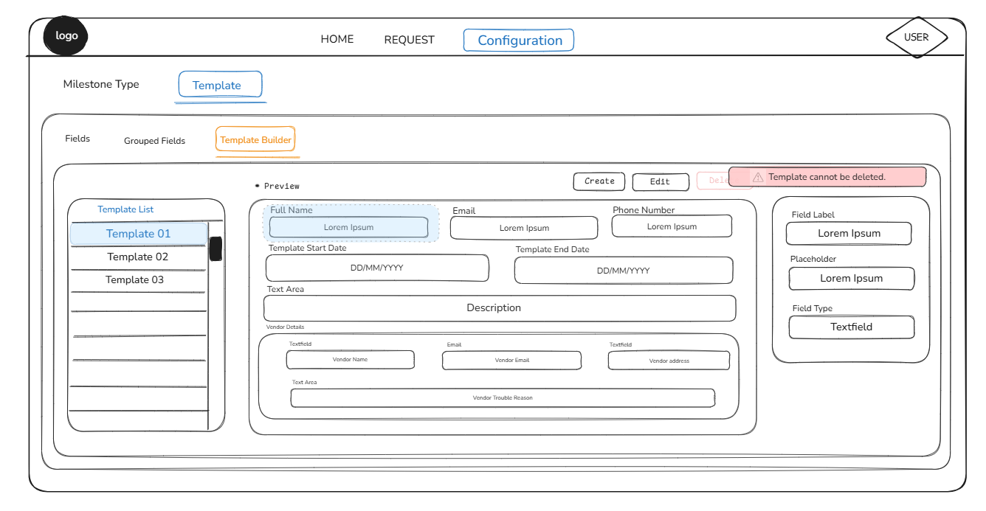
Figure: 13

When creating a new template or editing an existing one, the left pane is populated with a list of simple as well as grouped fields. The app admin can switch between the list of simple fields and that of the grouped fields by selecting the appropriate tab (refer to the picture below).
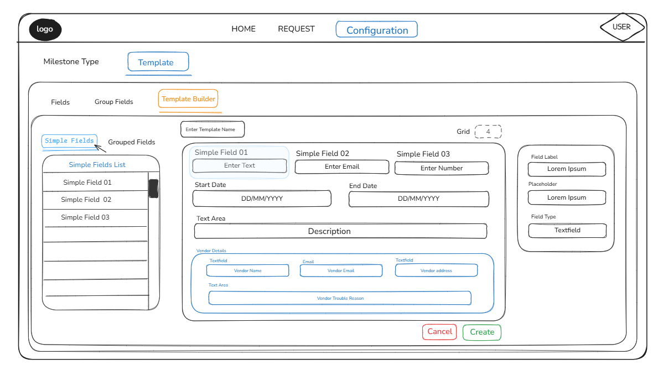
Figure: 14

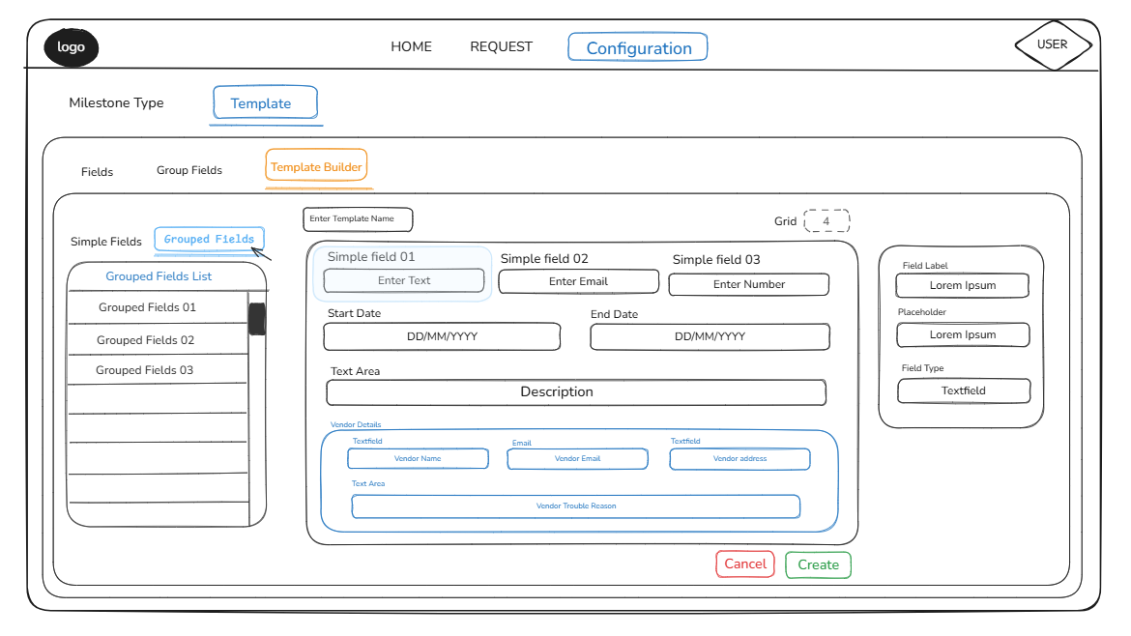
Figure: 15

- When designing a new template or making changes to an existing one, the member fields (simple or grouped) can be added by dragging them from the left panel and placing them on the layout builder to the right. Field widths of simple fields can be adjusted to accommodate multiple simple fields in a row.
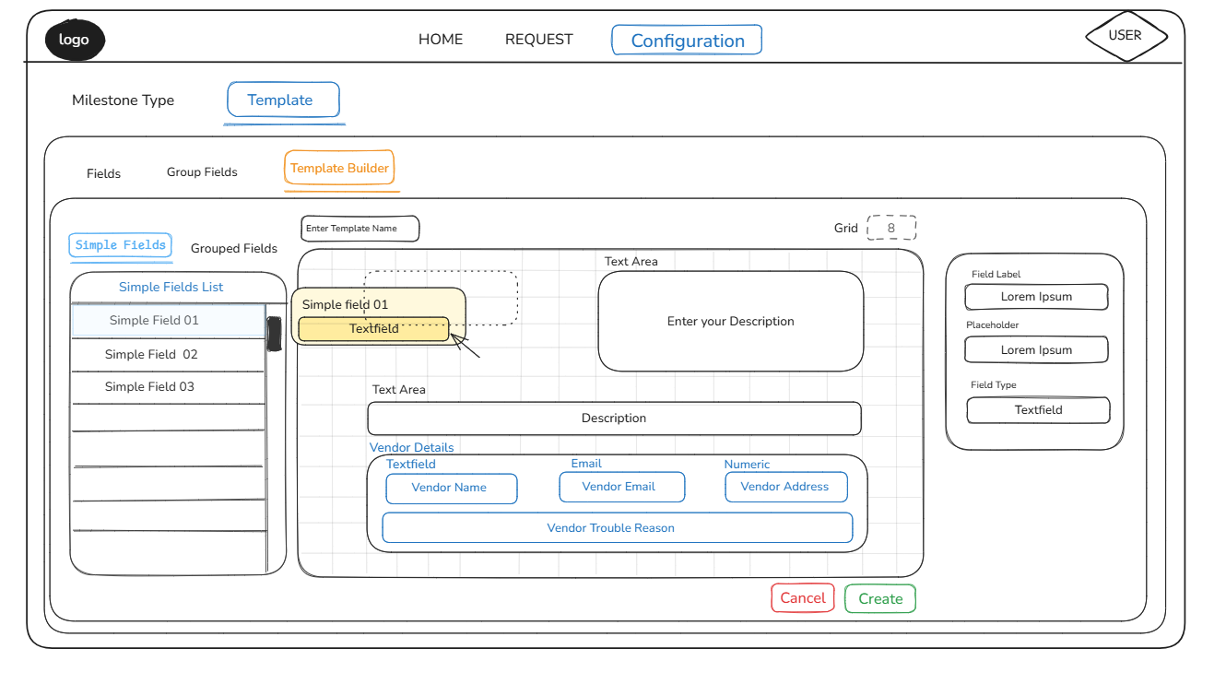
Figure: 16
- Similar to the layout builder for grouped fields, the default size of the layout builder grid is 16. However, this can be changed to a lower value for finer adjustment of simple fields with regard to their size and position. Size and position of grouped fields cannot be altered.
- Member fields (simple or grouped) pertaining to a template can be deleted by clicking the [x] mark that appears when hovering the mouse over the top right corner of that element.
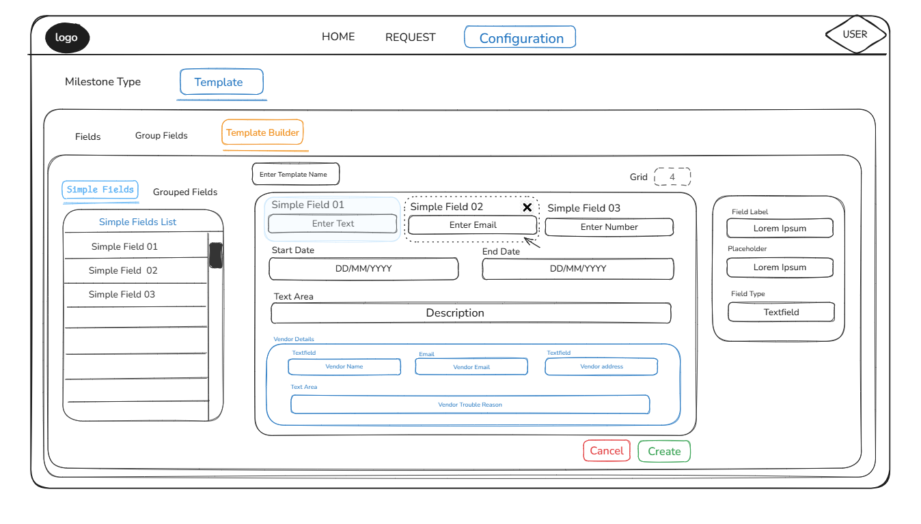
Figure: 17

